Case Study Report

# Improving Higher Education Supplementary Grant (HESG) Application Process

Business Analyst Portfolio Project

# Executive Summary & Business Context

This case study highlights a portfolio project simulating the role of a Business Analyst working with DSS to improve the Higher Education Supplementary Grant (HESG) application process. The project addressed poor UX, weak reporting, and high dropout rates. Quick wins, strategic recommendations, and improved data insights were delivered in an Agile framework.

# Stakeholder Analysis & RACI

|  |  |  |  |  |  |
| --- | --- | --- | --- | --- | --- |
| Stakeholder | Role | R | A | C | I |
| Henry Lee | Senior Director, DSS |  | A | C | I |
| Jane Harrington | Managing Director, Accenture |  | A | C | I |
| DSS Operations | Claim Processing | R |  | C | I |
| Students | End Users |  |  | C | I |
| Accenture BA | Business Analyst | R |  | C | I |

Business Requirements Document (BRD)

Fewer High-Level Business Requirements:

|  |  |  |
| --- | --- | --- |
| ID | Requirement | Priority |
| BR-01 | Improve receipt upload by allowing batch uploads | High |
| BR-02 | Validate bank details and DOB formats at entry | High |
| BR-03 | Provide real-time claim tracking to students | Medium |
| BR-04 | Standardise reporting metrics for management | High |

# Functional Requirements Document (FRD)

|  |  |  |
| --- | --- | --- |
| ID | Functionality | Acceptance Criteria |
| FR-01 | Batch upload of receipts | User can upload multiple files at once; system validates  for submission |
| FR-02 | Input validation | System checks DOB and bank format errors before  submission |
| FR-03 | Claim tracking dashboard | Students can view real-time status of claims |
| FR-04 | Data consistency reporting | Ops team can download standardised reports |

# Glossary

|  |  |
| --- | --- |
| Term | Definition |
| HESG | Higher Education Supplementary Grant |
| Claim | Student reimbursement request for educational expenses |
| Dropout | User abandoning application before completion |
| Dashboard | Visualisation tool for KPIs and reporting |

AS-IS vs TO-BE Process Flows

The AS-IS process shows multiple user drop-offs. The TO-BE design streamlines receipt uploads and adds validation.

[Process Flow Diagram Screenshot Placeholder]

# Business Model Canvas

[Canvas Visual Screenshot Placeholder

# Interview & Questionnaire Insights

Users highlighted difficulties in receipt uploads, repeated entry of personal data, and poor mobile usability. Staff noted frequent claim rejection due to simple errors, free-text misuse, and poor receipt image quality.

# Agile Way of Working

6 sprints delivered quick wins while defining a roadmap. Daily stand-ups, retrospectives, and backlog prioritisation ensured agility

# Prioritisation & Impact Matrix

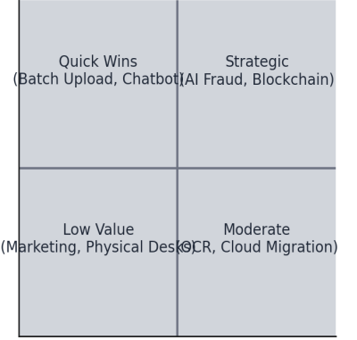

# Data Analysis & Dashboards

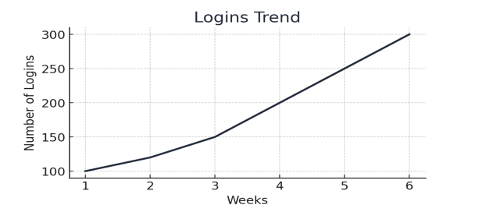

Funnel Analysis

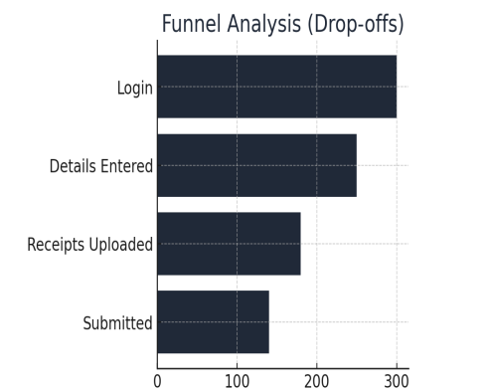 Error Categories

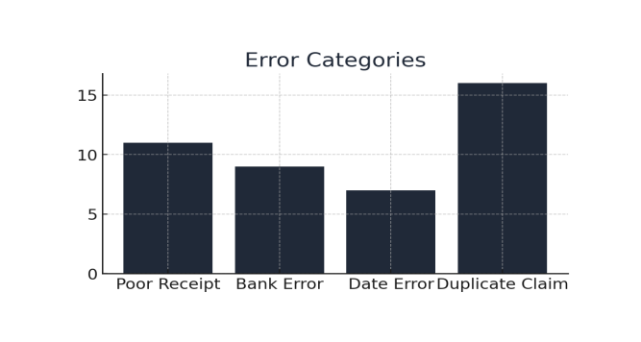

# Final Recommendations & Roadmap

Quick wins delivered: Batch uploads, validation rules, real-time claim tracking. Strategic roadmap: AI-driven fraud detection, cloud migration, blockchain integration.

# Key Skills Demonstrated

* Stakeholder Management • Requirements Elicitation & Documentation • Process Modelling • Agile Delivery • Data Analysis & Insights • Client Communication • Strategic Thinking